Monday 8th February 2021 WALT: identify gobblefunk and use alphabetical order
The BFG has a weird and wonderful vocabulary – this is called gobblefunk.
Task 1 – spot the gobblefunk in the extract below.
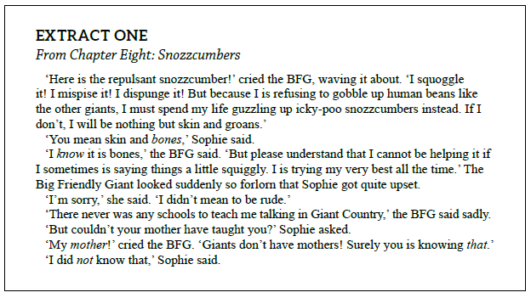
Task 2 – put the gobblefunk words you spotted into the table below thinking about which are adjectives (describing words), nouns (objects) and verbs (actions). There’s an example in each to help you.
Word type | Gobblefunk words
Adjectives (describing words) | Eg: rotsome
Nouns (objects) | Eg: chiddler
Verbs (actions) | Eg: jabbeling

Task 3 – put the gobblefunk words into alphabetical order (just like in a dictionary). You can use the alphabet strip to help you. Remember if two words start with the same letter, look at the second letter and so on.
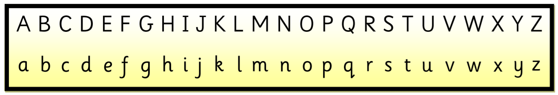
- fizzwiggler snozzcumber chiddler quelchy

- trogglehumper figgler whizzpopper scrumdiddlyumptious

- frightsome filthsome frobscottle flushbunkled

- gunghummers goggler gungswizzle gobblefunk

