Tuesday 9th February 2021 WALT: create a glossary (of BFG gobblefunk)
What are your favourite BFG words/gobblefunk?
Task 1 - Choose between 5 and 10 of your favourite BFG words and write them in the table below. Then put your chosen words into alphabetical order.
You can use the book to help you find your favourite gobblefunk words. 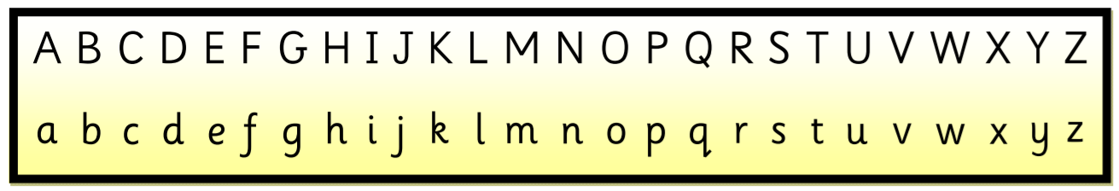
My favourite BFG words/gobblefunk | In alphabetical order
Task 2 – create a glossary using your favourite gobblefunk words.
A glossary is written in alphabetical order and explains the meaning of words. There are some examples below.
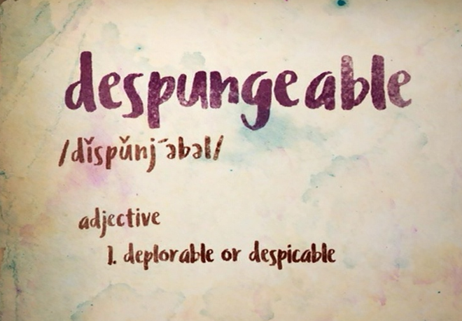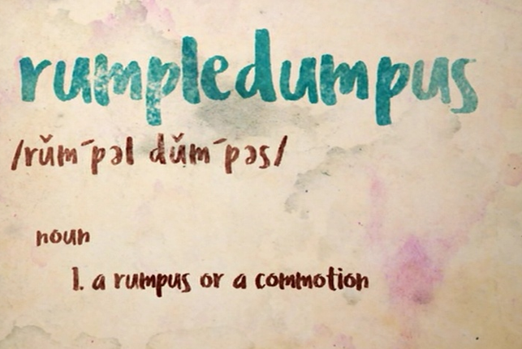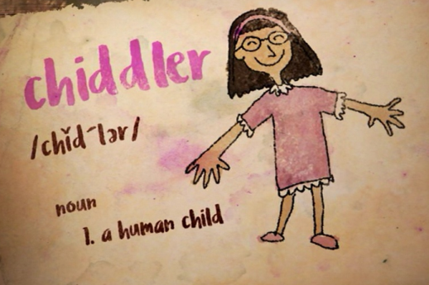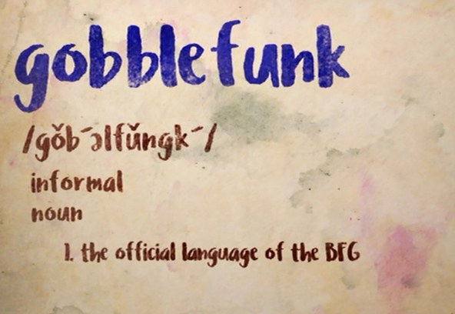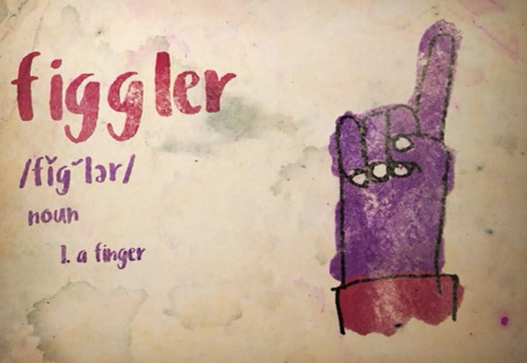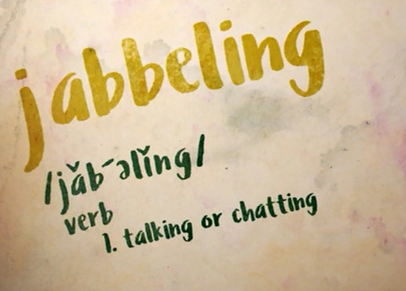
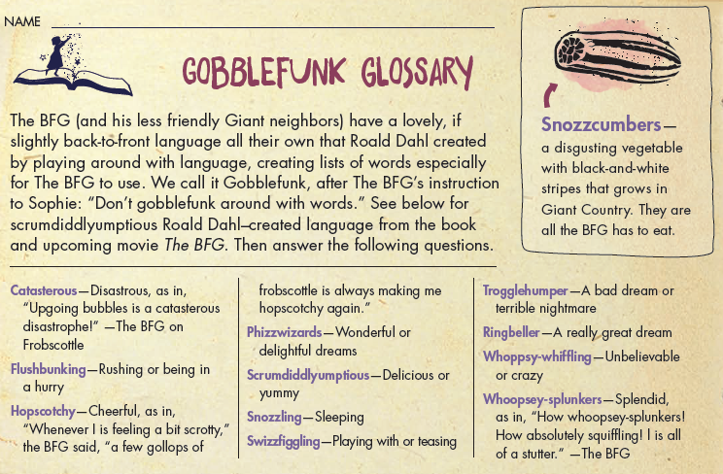
Be creative with how you create your glossary. You can create it below on this sheet, you can make your own mini book/poster or you might want to +create a google slide.
Remember it needs to be in alphabetical order and explain the meaning of each word.

