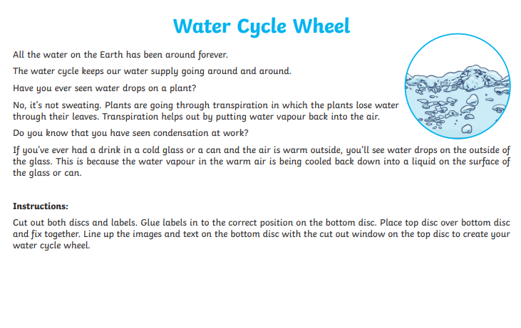
On the third sheet there are gaps that need filling with these key words: work out which words belong on which part:
Choose a label for each part from either – Precipitation, Collection, Evaporation, Condensation (can only be used once).
Then choose one group to complete the gaps under each heading (all of group 1 stay together, but will need putting in the correct gaps and order, the same for 2 – 4)
- liquid, clouds, gas
- rain, fall, sleet, heavy, hail, snow
- sun, heat, water vapour
- rivers, oceans, begins again, lakes


