SMSC – What’s an aspiration? Tuesday 2nd February 2021
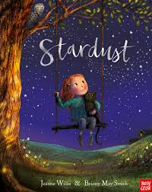
- Listen to the story Stardust by Jeanne Willis, Illustrated by Briony May Smith - Bing video

- Discuss these questions with a grown up
- What did the girl want more than anything in the world?
- How did she achieve it in the end?
- What is an aspiration?
- Do our aspirations all have to be the same?

- What aspirations do you have?
TASK – create a poster showing your aspirations. Be as creative as you can.



