WARM COLOURS Art lesson – Tuesday 26th January 2021
Look at the ‘warm’ colour images below and think about how you could use them to create a flame or fire image.
TASK – create a piece of art based on fire, flames or burning using warm colours.
You can use any art materials that you have available at home (crayons, felt tips, paint, paper, tissue paper etc.)
Take a photograph of your art work and attach it to the assignment.
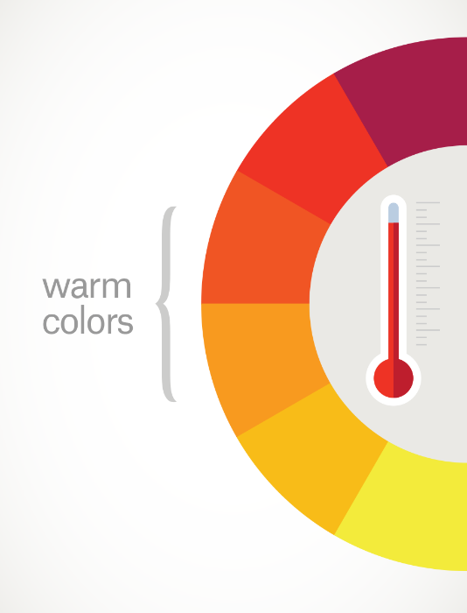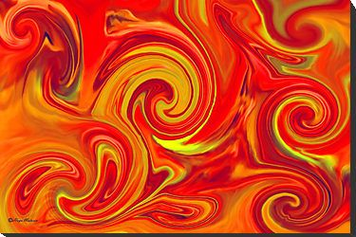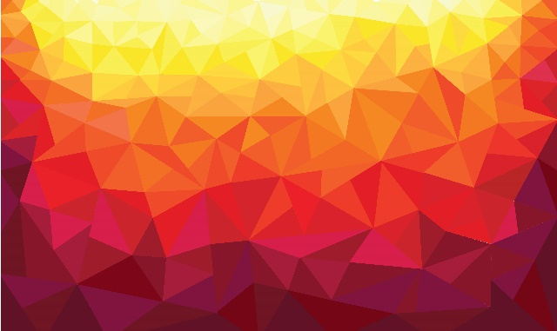
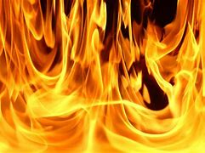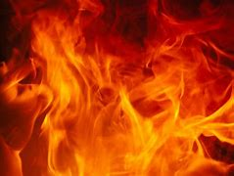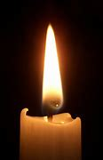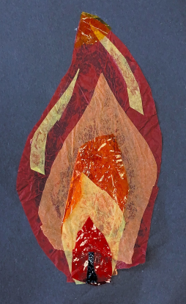
The last image is one I have done at school layering different colours and art materials.

