COOL COLOURS Art lesson – Thursday 28th January 2021
Look at the ‘cool’ colour images below and think about how you could use them to create an ice or iceberg image.
TASK – create a piece of art based on ice or icebergs using cool colours.
You can use any art materials that you have available at home (crayons, felt tips, paint, paper, tissue paper etc.)
Take a photograph of your art work and attach it to the assignment.
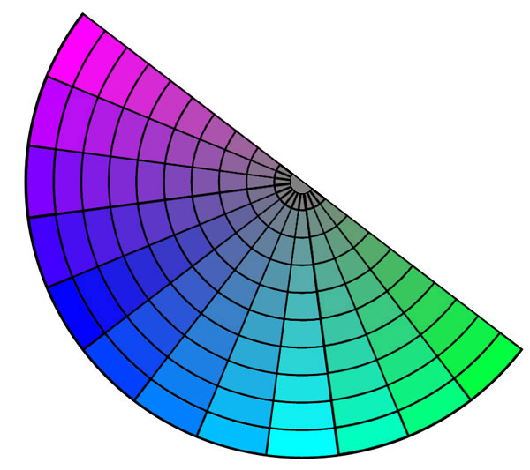

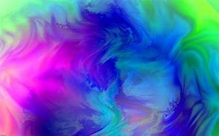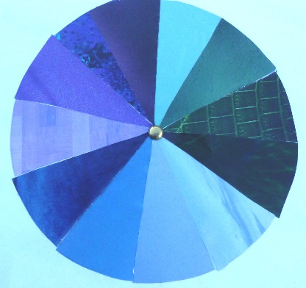
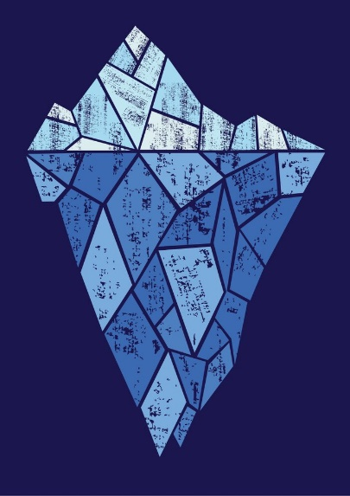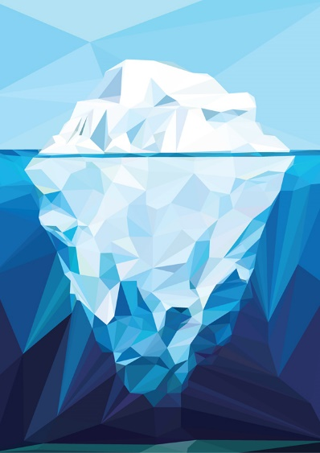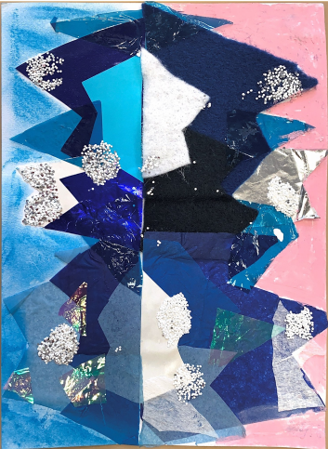
The last image is the art I have made at school using a reflection line as the sea level with the icebergs above and below the water. I’ve layered different colours and materials and used irregular shapes.

