Friday 26th February 2021 SMSC – What can I do about negative thoughts?
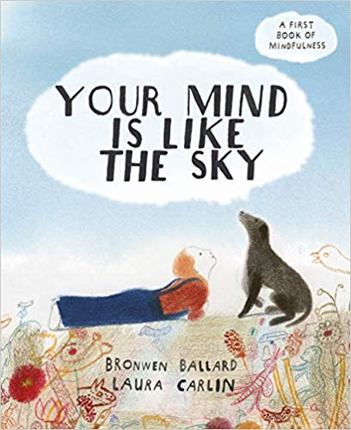 ‘Your mind is like the sky’ https://youtu.be/ErZ1zgjT0Vc

- Watch the video of the story ‘Your mind is like the sky’ on the link above.

- Discuss the answers to the questions below with a grown up at home:
How do raincloud (negative) thoughts make you feel?
How does the book tell us to deal with raincloud (negative) thoughts?
Have you had any raincloud (negative) thoughts?
What is mindfulness and how can you be mindful?
What could you do if your raincloud thoughts are getting you down?

- ‘I am an amazing person’ worksheet
We first completed this work sheet in September. We’d like you to complete it again thinking positive thoughts about yourself.
You may want to video yourself recording all the positive thoughts and send that in to us on google classroom or you can complete the sheet and send us a photograph.

You are all AMAZING and are doing AMAZING things!
We are very proud of you and can’t wait to have you all back in the classroom with us.

