WALT: create a piece of art or a model based on The World
Wednesday 3rd March 2021

Task – create a piece of artwork or a model of The World

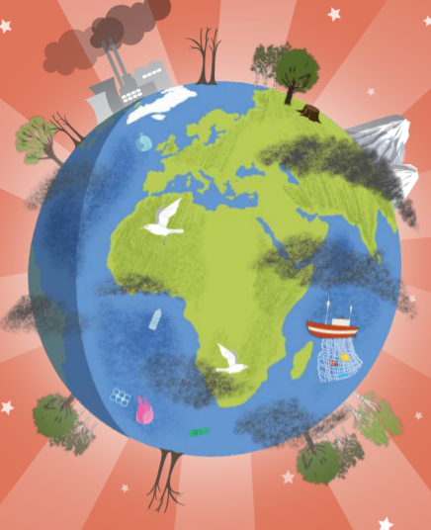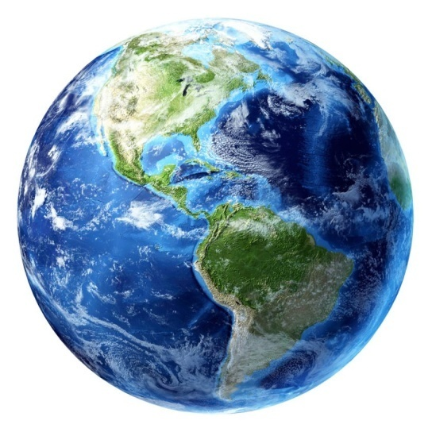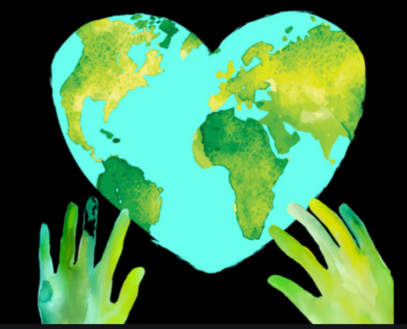
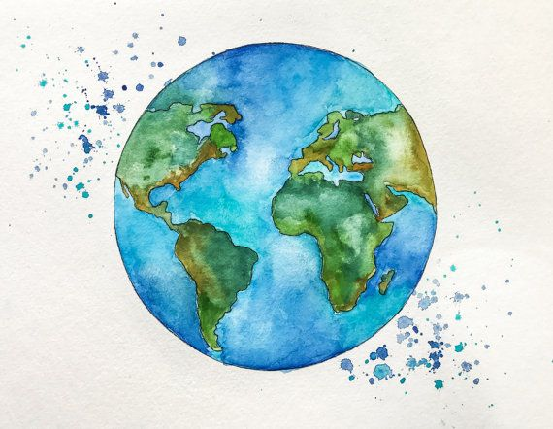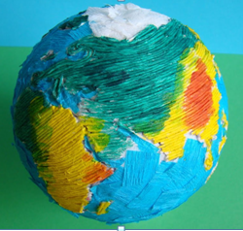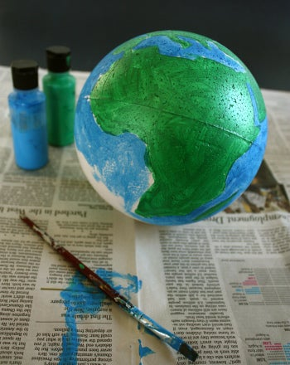

Think about:
- Shape
- Colours
- Size

Take time, care and effort to complete this task carefully and to the highest standard you can with the materials you have available to you.

