SMSC – Friday 5th March 2021
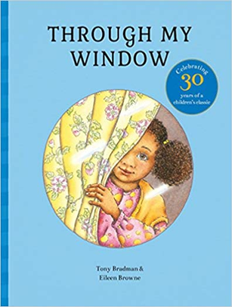 https://www.youtube.com/watch?v=xB5VJ9W_qmI
- What did Jo see out of her window?
- Describe the street that Jo lives on.
- What would you see out of your window?
- What types of people live in your area?
- What is your village or town called?
- What city is nearby? What county are you in?
- What landmarks or famous places are near where you live?

Task – Create a poster/slides/video with the tag line:
‘I’m proud of where I live because...’
You may want to go on a local walk and take some pictures of our local area to include

