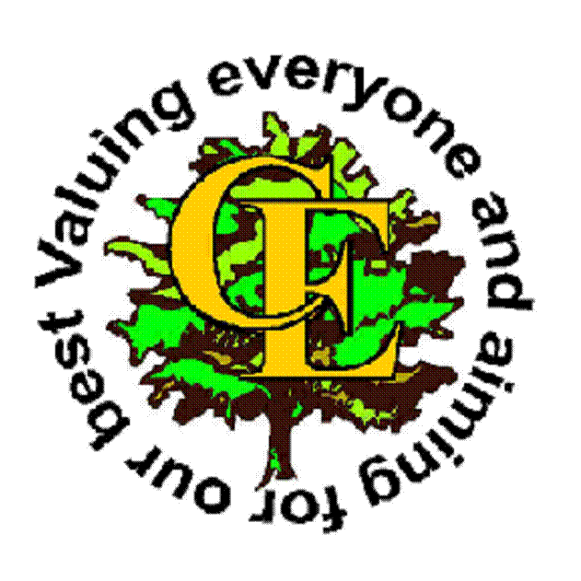
Chuter Ede Primary School Home Learning Key Stage 1

Head to the school website, follow the ‘Children’ tab and then the ‘Class Pages’ tab to find a new ‘Home Learning’ tab. Here you will find lots of links to help you with your work at home.

English

Keep up with your English whilst you’re at home by reading lots: books, recipes, instructions for games...anything you can find! Read together with your siblings and enjoy talking about what you have read. Practise your handwriting by writing the alphabet or a part of your favourite book. There are lots of websites to practise your phonics skills – take a look on the Year 1 learning page. You could keep a diary of your time at home, making a timetable of your day and illustrating it. Maybe you could make a snack for yourself and write a list of instructions, or create a story about your friends (and teachers?!).

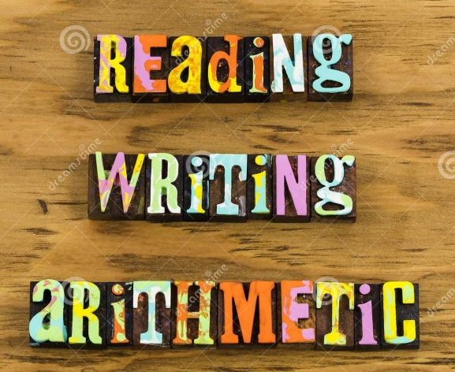

Maths

Now is a really good chance to make sure that you can write all of your numbers the right way around. Why not practise writing them with a paintbrush and water, in flour or tracing them into a notebook. There are lots of other great websites where you can practise your maths skills – look for links on the ‘Maths’ part of the Year 1 children’s page. Maybe you could make up some of your own calculations to have a go at. We have been practising lots of adding and taking away.

Keep your eyes on the ‘KS1 Home Learning’ tab as we will add to it as we find other useful links and information.

Home Learning Project – See separate sheet uploaded

