Handa’s Hen book review by Eileen Browne
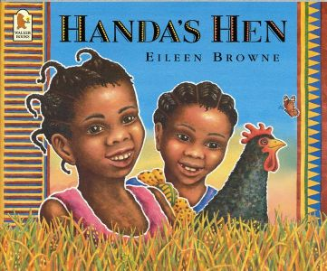
Handa's Hen is a sequel to Handa’s Surprise. Handa is searching for her grandma's black hen, Mondi. Every morning, she feeds Mondi her breakfast, but this morning Mondi hasn't come for her food. So Handa and

her friend Akeyo begin to hunt for Mondi. While searching, they find two fluttery butterflies, three stripy mice, four little lizards, five beautiful sunbirds, six jumping crickets, seven baby bullfrogs, eight spoonbills and nine shiny starlings! The girls were getting worried that Mondi had been eaten by the spoonbills or even a lion. Cheep, cheep! They finally discover Mondi and her ten fluffy chicks.

Handa’s Hen is beautifully illustrated with animals, plants and people of Kenya. Handa and Akeyo’s journey shows village houses, farmyard storage areas and domestic utensils. This picture book is great for early years as it is a story that develops children's counting skills.
Handa’s Hen is also produced in a big-book format and it is a fantastic resource to use in the classroom.

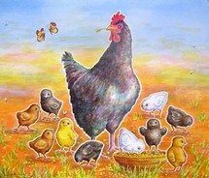

  All groups  In your book | Handa’s Hen  Comprehension |   In your head
1. Who is the author of Handa’s Hen? ___________________
2. What other books has this author written?
__________________________________________________________
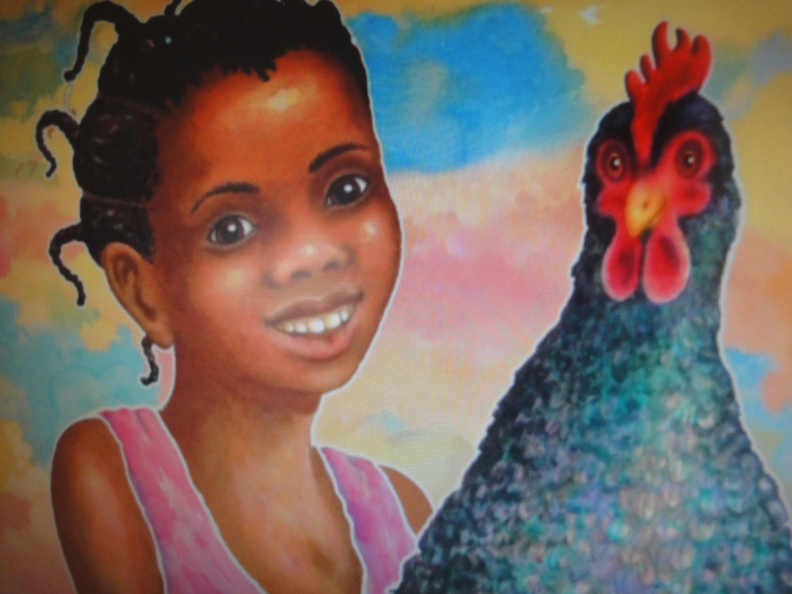
3. When does Handa feed the hen?
_______________________________________________________
4a.Circle the noun groups in red.
4b.What other creatures did Akeyo and Handa find while searching for the hen? (Remember commas)
_________________________________________________________
_________________________________________________________

5. Where does this story take place?

6. Why do you think a teacher would like to use Handa’s
big book in the classroom?_______________________________
_________________________________________________________
7. List how many different types of birds there are in this story? _________________________________________Sandy

