
Main Characters
________________________________________________
__________________________
__________________________
_________________________
____________
Author
____________________
Setting
time_______________________
__________________________
place______________________
_________________________
_________________________
____________
Author
____________________

Handa’s Hen
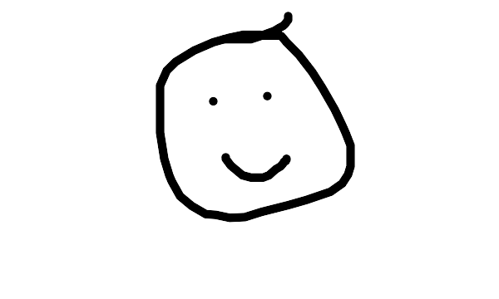
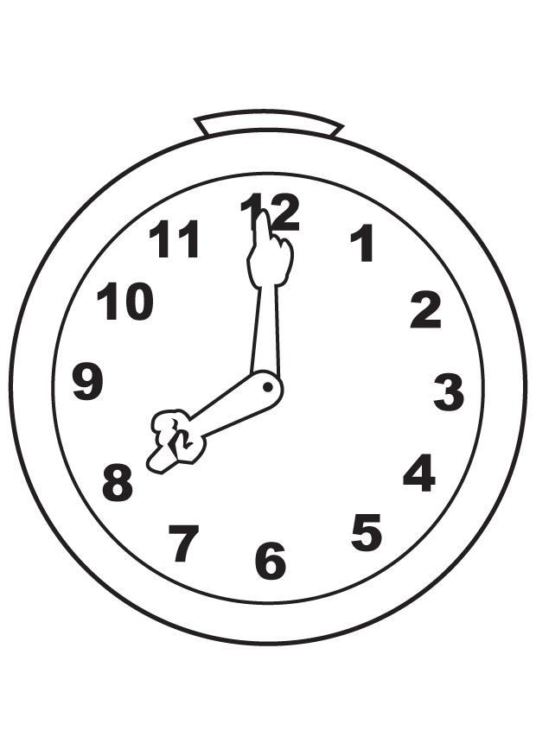

Title
____________________________
Author
____________________
Problem
________________________________________________

Solution
________________________________________________

