Physical and Human Features
Label the pictures. Human or physical
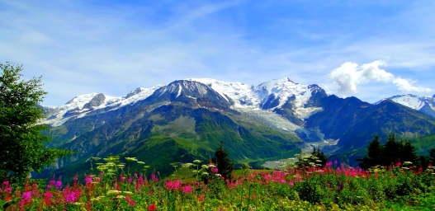



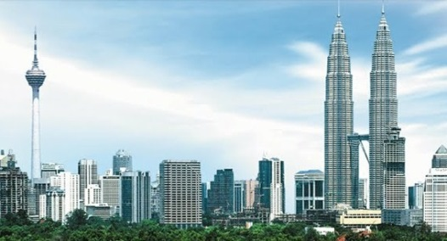

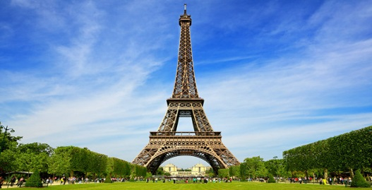

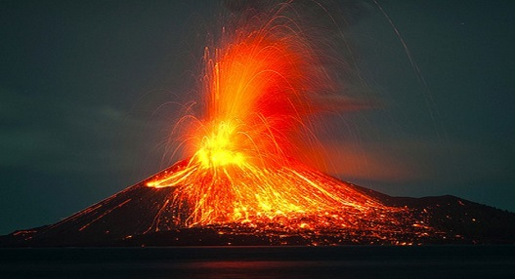

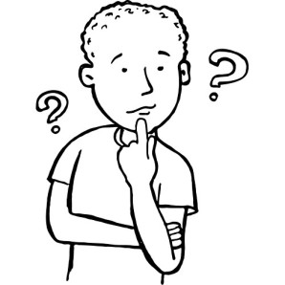
Can you tell me what a physical feature is?

What about human feature?

human | human
human | human
human | human
physical | physical
physical | physical
physical | physical
human
human
human
physical
physical
physical

