b | English warmup | English | Phonics warmup | Phonics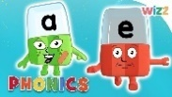 | Maths warmup | Maths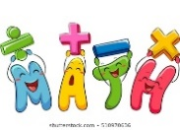 | TOPIC Work  
Monday | Can you remember the days of the week in order? Sing the song  Days of the Week song | The Party – Listen to Mrs Allen reading the short text. Can you listen really carefully and answer Mrs Allen’s questions at the end?  The Party activity – can you complete the sheet by drawing a picture of the kite and writing a sentence about why Anita was sad? | Listen to the phoneme (sound) and match to the diagraph.  Grab a Giggling Grapheme (phonicsplay.co.uk)  Log in jan 21  Password home | Trigraph ‘air’ Louisa’s lesson.  Practise saying, reading and writing words with the ‘air’ in.  Activities -  The air sound | Phase 3 Phonics | air words - BBC Bitesize  If you enjoyed Geraldine last week see what she finds with ‘air’ in.  Geraldine the Giraffe learns /air/ - Bing video | Practicing numbers from 11-20  Listen to the songs and practice counting and writing your numbers from 11-20.  https://youtu.be/aDPPHVG6TAE  https://youtu.be/al5OqpARGD8  Can you match them to the tens frames? | Watch and listen to Miss Woodcock’s video all about place value.  Now can you draw your own tens frame and tens and one's chart. Find some objects in your house and practice making different teen numbers. What numbers did you make?  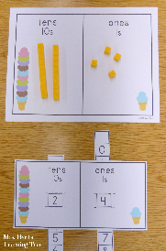 | R.E  Noah's Ark - Storynory  Listen to the story of Noah’s Ark  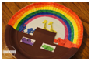  If you have a paper plate, you could try the Noah’s Ark craft too!
Tuesday | Days of the week spelling practise  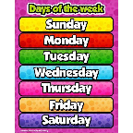 | Watch the opening trailer to Toy story which can be found on Google Classroom. What toys did you spot in Andy’s room? Can you write a list of some toys that are in your room?  Toy clues activities. Use your phonics to help you read the clues about some toys. Can you find the right toy to match?  Challenge – can you write some clues for your teacher about a toy and send them in for us to guess? Or make a video of you giving us some clues. If you like we could share your clues with the class on the stream for them to guess. | Phased 3 mat – fastest finger your grown up says a diagraph or trigraph for you to find.  Use phase 3 mat from last week.  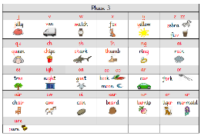 | ir, ur and er.  We have now learnt three different ways to write the ‘er’ phoneme. Can you read and sort the words – look for the diagraphs. Do you notice anything?  Activity sheet ‘er’ ‘ur’ and ‘ir’.  Nessy Spelling Strategy | er ir ur Words | Learn to Read - Bing video  Listen to the song ...  Bossy 'r'/ Controlling 'r' / Long Vowel 'ur/ir/er' - Phonics Song - YouTube  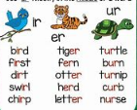 | Let’s practice counting in 2’s and 5’s !  https://youtu.be/JyCr0IgbYcI  https://youtu.be/amxVL9KUmq8  Can you count to 30 in 2’s and 5’s?  Order your numbers from 1-30.  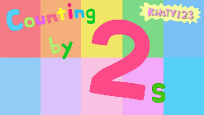 | Watch the video of Miss Woodcock playing a game using base ten.  Can you have a go at playing the game? What number is being shown using the base ten? Try numbers up to 29.  http://www.ictgames.com/sharkNumbers/mobile/index.html  Then let's play some bingo! What numbers did you manage to match?   | PE  Joe Wicks follow one of his workouts or look at the cards to practise some exercises.    History – we have looked at old and new toys over the past few weeks.  Can you sort the toys in the two groups old and new? 
Wednesday | Do you know what a suffix is? Go on BBC bitesize to learn all about them.  BBC bitesize suffixes | Watch next part of Toy Story where Woody meets Buzz. Look really closely at Woody and Buzz’ faces – how are they feeling? Are they happy to meet each other? Do they like each other?  Look at Mrs Allen’s PowerPoint video to have a think about what the characters might be saying to each other.  Can you write some speech bubbles pretending you are Woody and Buzz? | Recap ‘ar’ write down all the words that have an ‘ar’  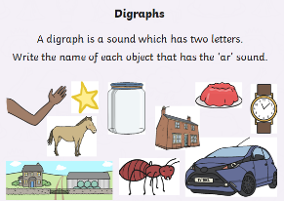 | Trigraphs = igh  Watch Louisa’s ‘igh’ video and practise your blending.  Alphablocks - Volume 3 Episode 7 - Tightrope (Trigraph IGH) - Bing video  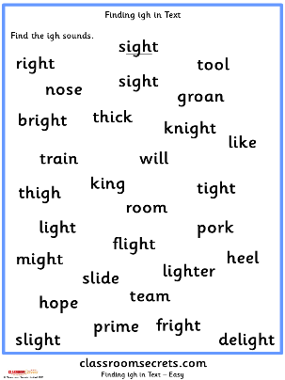 | Watch the clips on money.  https://www.bbc.co.uk/bitesize/clips/zbnyr82  https://www.bbc.co.uk/bitesize/clips/z426sbk  Then practice your money skills.  https://www.topmarks.co.uk/money/toy-shop-money  Here is a challenge for you!  https://natwest.mymoneysense.com/students/students-5-8/coin-cruncher/ | Watch the lesson on counting forwards and backwards in 50!  https://www.youtube.com/watch?v=wR09sn8u3AM  Using the hundred square, can you finish the activities to practice counting forwards and backwards.   | ICT – J2code lesson 2  Hope you had fun last week learning how to code now let’s move on to lesson two.
Thursday | Suffix quiz. Can you remember what you learnt about suffixes yesterday? Have a go at the quiz on Google Classroom.  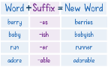 | Watch Mrs Allen’s video – she has got a post card from Andy! Can you work out where he is?  Check google classroom – do you have a post card from Andy? Can you read it and draw a picture of where he is.  The picture will appear on google classroom at 3pm for you to compare your picture to the real picture! | Keywords – read spring term keywords. Which ones are tricky? How many can you read?  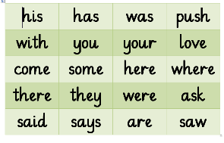 | Pick A Picture (phonicsplay.co.uk)  Picnic on Pluto (phonicsplay.co.uk)  Log in jan 21  Password home  Choose a game and practice phase 2, 3 and 4. Which ones are you finding tricky? Let us know we will plan these in next week. | It is time to practice our shapes!  Warm up with Miss Woodcock and sing along to the songs.  https://youtu.be/WTeqUejf3D0  https://youtu.be/2cg-Uc556-Q  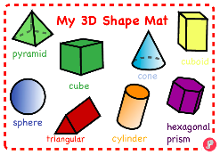 | Go through the PowerPoint counting between 1 and 50.  You have TWO activities to choose from to practice your tens and ones. Which one will you pick?  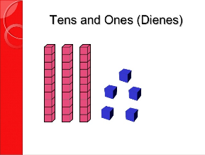 | Art  Make a whirlygig toy out of paper, card and string. See website:  How to make a whirlygig | The Craft Train  Watch the video and then make this toy.   What patterns and colours can you use?  PDF template doc
Friday | Spelling quiz. - focus on our key words sent on Monday.  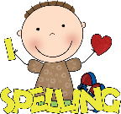 | Create your own Mr Potato head like Mrs Allen’s in her video. Watch how she uses adjectives to describe him.  Can you write some words around him or sentences to describe what he is like? | Phonics play Space race  Choose a phase and have a go at spelling the words.  Space Race (phonicsplay.co.uk)  Log in jan 21  Password home | Trigraph ‘ear’ watch Louisa’s video to practise reading and writing ‘ear’.  ‘ear’ wordsearch for extra practice to read and find the words. | Practice counting forwards and backwards, one more and one less with Foxy!  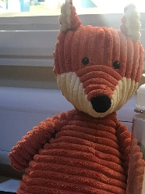 | Watch the video of Miss Woodcock making numbers between 1 and 50 in different ways.  Now you have TWO activities to choose from, which one will you choose?    Maybe try the SUPER STAR CHALLENGE? | Music  High and low pitch  Watch the cartoon with the different instruments then join in with the song ‘I hear thunder’. There’s a colouring sheet with wet weather sounds to colour too.

