b | English warmup | English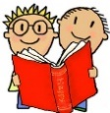 | Phonics warmup | Phonics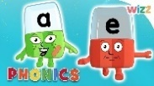 | Maths warmup | Maths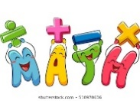 | TOPIC Work  
Monday | What is an adjective? Sing along to the adjective song. Can you now write some adjectives that describe you?  https://youtu.be/QxoDGlPUmyU  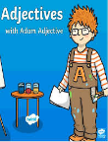 | This week we are going to be thinking about instructions, what they are and how we write them.  Have a look at the video of Miss Woodcock talking about instructions.  Can you find any instructions in your home? Add a picture if you wish.  Afterwards can you order the instructions for making a jam sandwich 🍞Then using the instructions can you make a jam sandwich and send a photo of your sandwich and instructions. 📷  Don't worry if you don't have jam, maybe you could use another filling? | Countdown – have the list of cvc (easier) or ir (harder) words in front of you. Get a grown up to time you how long it takes to sound out and read them all? Can you do it again but this time a bit quicker?! | Digraph ‘ai’ phonics session.  Can you sound out and blend some ai words?  https://www.youtube.com/watch?v=JDzpV3jFefs  Would you like to do an ai wordsearch? | Number bonds song – we don’t want to forget our number bonds.  Here is a moving song to help remind you. KS1 Maths: Number Bonds with Martin Dougan - BBC Teach | This week we are going to start looking at one more and one less  Slideshow with video to complete short tasks to begin with.  Tasks are optional -  Bee Hive - More & Less (ictgames.com) | RE – The Loaves and Fishes story.  Can you make a basket full of bread loaves and fishes?  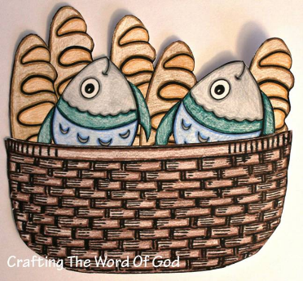
Tuesday | What is a verb? Sing along to the adjective song and have a look at the powerpoint.  https://www.bbc.co.uk/bitesize/topics/zrqqtfr/articles/zpxhdxs  https://youtu.be/M-_Wky0BNk0   | Today we are thinking about imperative verbs! These are very bossy verbs and tell you to do something, they are at the start of sentence and turn it into a command.  Watch the video 'bossy verbs making toast' and then watch the video of Miss Woodcock talking through imperative verbs.  Can you order the instructions for getting ready in the morning and highlight the bossy verbs? 🛏🛁🚿🚽  There are two versions to choose from, which one suits you best?   | Would you like to name an alien? What name would you give the alien? Use the sounds to come up with some strange sounding names! | Digraph ‘ay’.  Have a look inside your books at home. Can you find words with the ‘ay’ digraph in? Have a go at sounding them out and blending them.  Can you spot the difference between ‘ay’ and ‘ai’? sort out the ai and ay words and see if you can think of a rule for when you use ay or ai in a word. | Mrs Adwick is going to put coins in the pot do you know how much? You will need to use your counting in 2’s, 5’s and 10’s skills to help you.  Here are some songs that might help.  Counting By Twos Song - Bing video  The Counting by Fives Song | Counting Songs | Scratch Garden - Bing video | Continue with one more and one less  Follow the slide show and complete the tasks.  Play the game below or complete a one more and less task.  Bee Hive - More & Less (ictgames.com) | Science – floating and sinking. Watch the video of Mrs Allen experimenting with objects that float and sink. What can you find that floats and sinks? Use the activity sheet if you would like some ideas but feel free to find your own objects!  If you would like to- make us a video or send us some photos.  https://www.sesamestreet.org/toolkits/stem/sink-or-float  PE – Do you fancy doing some yoga this week? There are lots of videos to choose from on cosmic kids yoga and also some different poses to try on Google Classroom
Wednesday | Recap bossy verbs, using the pictures below can you write an instruction using your bossy verbs   | Watch the video of Miss Woodcock describing her toy whilst her friend draws it.  Choose a picture of a toy (old or new) and describe it to your adult at home.  Don't show the toy, but think about using clear and accurate descriptions. Think about how you would describe the toy, remember your time words, first, second, next, finally etc  Can you use some bossy verbs such as draw, colour...  Take a picture of the drawing and the toy next to each other. Are they the same?   | Are you good at rhyming? Listen to the story Aliens Love Underpants. Can you spot the rhyming words? | Split vowel digraph a-e session. Learn about what a split digraph is by watching the video.  Play buried treasure with the split vowel digraph a-e. Which are real and which are alien?  https://www.phonicsplay.co.uk/resources/phase/5/buried-treasure | Counting forwards and backwards with the mover video.  KS1 Maths: Counting with John Farnworth - BBC Teach | Comparing objects to 50  Watch the video of the introduction of crocodile mouths linked to greater than and less than. Can you compare objects.  Use the crocodile mouths to make some number sentences practically using objects or have a go at one of the activities. 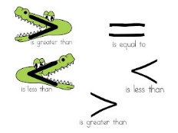 | ICT j2 code – Let's have a go at animating. Follow the links on google classroom and watch the video for a how to.
Thursday | What is a noun? Watch the video about nouns and what they are. Now let's go on a noun hunt!  https://www.bbc.co.uk/bitesize/topics/zrqqtfr/articles/zpd8ng8  https://youtu.be/m-CiedPia_U   | Watch the video of Stefan Gates making a sharing cake. He is writing his instructions.  What types of words did he use?  What were some of the imperative verbs/adjectives he used?  What sort of imperative verbs are used?  What did he do first? What happened next?  Now we are going to make a toy. Use the pictures to make the toy and think about what you are doing. What did you do first, second etc. What actions do you use, cutting, painting, sticking. 🖍🖌✂️  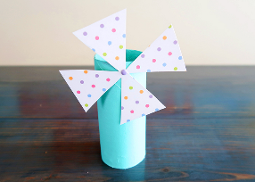 | Rhyming pants. Can you think of some words to rhyme with the pants? | Can you remember learning about the split vowel digraph a-e yesterday? Do you like Geraldine the giraffe? Watch her learning all about a-e.  https://www.youtube.com/watch?v=jkycxr-joDk  Find the a-e words in the picture. Can you have a go at spelling them? | Daily ten – play this game practise number bonds to 10 or 20 how quick can you answer the questions?  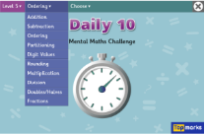 | Ordering numbers to 50  Both these games are good to practise  Caterpillar Ordering - An Ordering and Sequencing Game (topmarks.co.uk)  Coconut Ordering - Comparing Numbers, Prices, Mass, Length and Capacity (topmarks.co.uk) | Art – using cardboard from your home recycling, can you make a toy? Look at the Art Bank sheet for some ideas!
Friday | It is BINGO time again! Lets practice our key words.  Maybe make your own bingo crown? 👑   | Watch the writing instructions video.  Now we are going to write instructions for the toy we made yesterday. Have a good think, what title do we need? what equipment did you use? What did you do first? What came second? What pictures could we include?  Remember, what time words do we use in our instructions? What bossy verbs can we add? Could you use an adjective to describe some equipment?  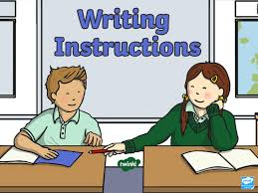 | Sound maze! Follow the maze to find the sounds to make the right word. | Are you ready for a bit of bingo? Get your bingo boards at the ready. Watch the video to play along. Can you find all the words and shout BINGO!? | Mental Maths Train - A Four Operations Game (topmarks.co.uk)  Choose addition and pick up to 10 or up to 25 have a go at solving the calculations.  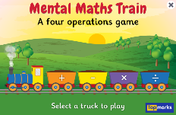 | Counting in 2’s  Counting on and back in 2s within 50 - Year 1 - P2 - Maths - Catch Up Lessons - Home Learning with BBC Bitesize - BBC Bitesize  Counting in 2s | Song of Twos | The Singing Walrus - Bing video  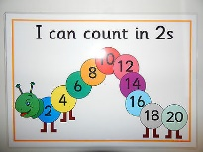 | PSHE Talking points - What makes me happy?  Watch the story . Augustus and His Smile read by the author.  Have a go at answering the questions about what makes you happy.

