 | English warmup   | English   | Phonic Option 1  Blending | Phonics Option 2   New sounds | Maths warmup | Maths  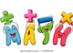 | TOPIC Work
Monday | Autumn key words practice or moving on to Spring key words  On google classroom and website | Listening to or reading The Paper Dolls.  Afterwards complete the Monday activity on google classroom. Can you write about who the paper dolls would meet if they came to your house and who would they see?  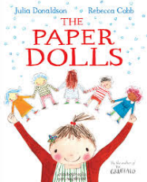 | Lesson 1 - ar dark - YouTube  Ar activity on website or in google classroom  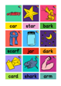 | Lesson 31 - Year 1 - YouTube  Ay activity on website or in google classroom 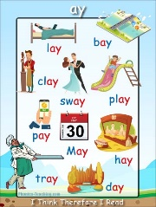 | Numbots – if you can log on if not let us know and we will get sorted.  Maths Quiz on Google Classroom to complete | Measures -  To compare lengths and heights of objects (thenational.academy)  Activity in maths folder  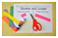 | RE – Read the bible story of the Lost Coin. Can you cut out and stick the pictures in order to retell the story?
Tuesday | Spellings Quiz  Google classroom | Reading task for the paper dolls. Can you listen to the story and answer the questions on the word document? Your adults can help you.  Google classroom- English Tuesday activity   | Lesson 2 - or born - YouTube  An activity to follow video is in the folder on website or in google classroom  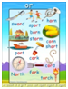 | Lesson 32 - Year 1 - YouTube  An activity to follow video is in the folder on website or in google classroom  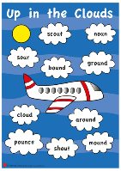 | Practical counting – using 10 pairs of socks. Can you count forwards/ backwards? Can you pair the socks and count in 2’s? Can you guess (estimate) then count? More than/less than a number?  Maths Quiz on Google Classroom to complete | Measures -  Compare length and height - Year 1 - P2 - Maths - Catch Up Lessons - Home Learning with BBC Bitesize - BBC Bitesize  Make Lego/ Duplo towers and compare heights. tall, taller and tallest, short, shorter, shortest  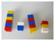 | PE – Joe |Wicks do you fancy joining him for one of his live sessions. Or go on a bike ride, walk or on your scooter.
Wednesday | Comprehension quiz  Google classroom | Writing a sorry letter  The little boy cut up the paper dolls. Oh no! Can you write a sorry letter from the little boy to the little girl to say sorry?  Google classroom-English Wednesday activity  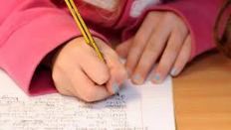 | Lesson 3 - ur fur - YouTube  An activity to follow video is in the folder on website or in google classroom  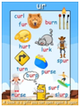 | Lesson 33 - Year 1 - YouTube  An activity to follow video is in the folder on website or in google classroom  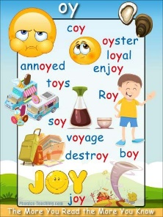 | Numbots – if you can log on if not let us know and we will get sorted.  Maths Quiz on Google Classroom to complete | Measures – Using a piece of wool/ string measuring 30cm find something that is longer/shorter/ longest/ taller than the string. | ICT -  Look at Buddy the Dog’s internet safety PowerPoint on Google Classroom  Play obb and bob on phonics bloom. Select phase 3 or 4.  https://www.phonicsbloom.com/uk/game/odd-and-bob?phase=4
Thursday | Spelling quiz google classroom | Instruction writing  Can you write some instructions on how to make paper dolls? Or can you match the instruction to the right picture? There are different sheets for you to choose from.  Google classroom- Thursday English Activity.  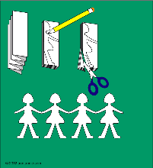 | Lesson 4 - ow owl - YouTube  An activity to follow video is in the folder on website or in google classroom  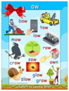 | Lesson 34 - Year 1 - YouTube  An activity to follow video is in the folder on website or in google classroom  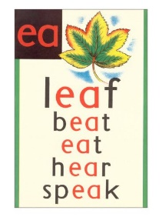 | Number Hunt – look round the house and see how man numbers you can find – time yourself for 3 mins  Write them down as you find them.  Maths Quiz on Google Classroom to complete | Measures – Using a ruler, practice drawing straight lines and look at how to measure in cm. Activity in maths folder  Measuring in Centimetres (topmarks.co.uk) | Art – sock puppets.  Watch Mrs Allen’s video all about sock puppets.  Can you design a sock puppet using the template ready to make next week?
Friday | Phonics quiz google classroom | Memory writing  In the Paper Dolls the little girl grows up to be a mummy, she makes the paper dolls with her daughter. Talk to your mummy, daddy and grandparents, what did they play as children? Can you record your findings?  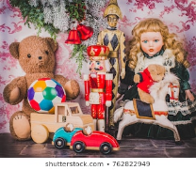 | Review of the week  Lesson 5 - Review the week - YouTube  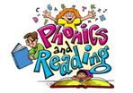 | Lesson 35 - Year 1 - YouTube  An activity to follow video is in the folder on website or in google classroom | Numbots – if you can log on if not let us know and we will get sorted.  Maths Quiz on Google Classroom to complete | Measures –Who is the tallest/ shortest in your family/friends – draw a line up of people from shortest to tallest. Can you write their names?  Prompt in folder to go on GC | Music – Listen to this piece of music – You've got a friend in me by Randy Newman. How does it make you feel? Can you draw a picture of what it makes you think of?

