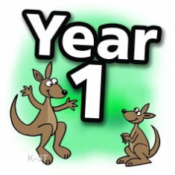

Date 11.1.21

If your child is working on blending skills in phonics this is their week’s worth of phonic sessions. Use the videos as best suit your child. They model phonic sessions we would be doing in school. (Don’t worry about the date on the videos)
There is a short activity they can complete and hand in to us.
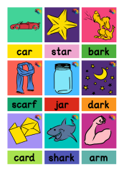
Monday
Lesson 1 - ar dark - YouTube
Activity – ar
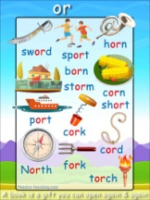
Tuesday
Lesson 2 - or born - YouTube
Activity - or
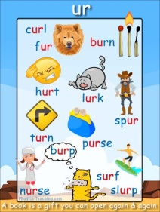
Wednesday
Lesson 3 - ur fur - YouTube
Activity - ur
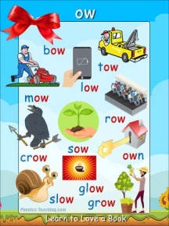
Thursday
Lesson 4 - ow owl - YouTube
Activity – ow
Friday
Lesson 5 - Review the week - YouTube
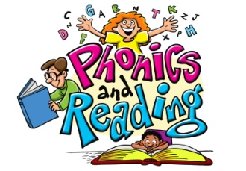
Activity - Review of the week

