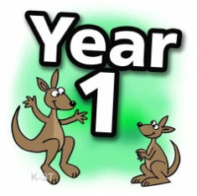

Date 11.1.21

If your child is secure with blending and ready to learn some new sounds the follow this plan of work.

Monday
Lesson 31 - Year 1 - YouTube
Activity – ay in play
Tuesday
Lesson 32 - Year 1 - YouTube
Activity – ou in cloud
Wednesday
Lesson 33 - Year 1 - YouTube
Activity – oy in toy ( recap from last week)
Thursday
Lesson 34 - Year 1 - YouTube
Activity – ea in treat
Friday
Lesson 35 - Year 1 - YouTube
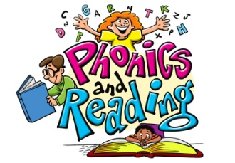
Activity - Review of the week

