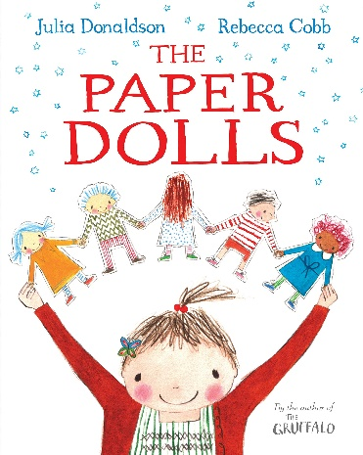
Reading Comprehension Questions:
‘The Paper Dolls’ by Julia Donaldson.
With an adult listen or read the story again. Using the story can you answer these questions? Type your answer in independently or ask your parents for help.

- What animal does the girl have on her slippers?
- What part of the girl’s room has stars on it?
- What does the girl keep losing?
- How many goldfish does the girl keep as pets?
- What does the girl’s mother help her to make?
- Tell me at least one thing that the paper dolls do.
- Are the dolls scared of the dinosaur? Tell me how you know.
- What word beginning with f tells us how they got away?
- What do you think it means when it says the crocodile gnashed his teeth?
- Who comes along with a pair of scissors?
- Why do you think the boy cuts up the paper dolls?
- How do you think the girl feels?
- How does this make you feel? Can you tell me why?

