Name:__________________ Date:________
I answer questions about handling data
Here is a block graph showing Rowan class’ favourite fruit.
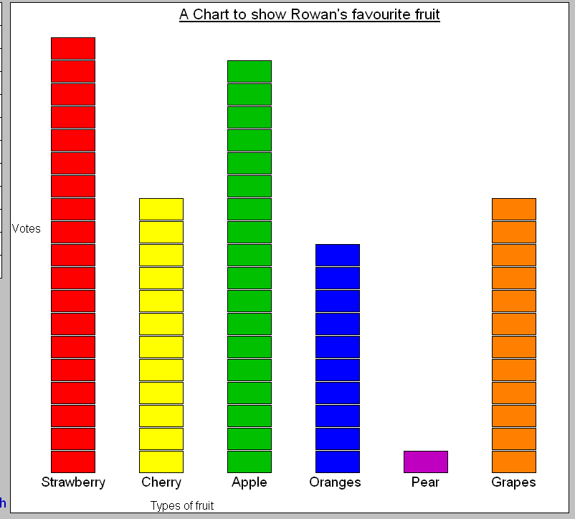
1. First, can you correct the graph? Pear has been given 1 vote, but it should have 4! Can you make it so Pear has 4 votes?

Then can you answer the following questions?

2. How many more people voted for strawberry than cherry? ________

3. Which fruit got the most votes? ____________________________

4. Which two fruit got the same amount of votes? _______and_______

5. How many people voted for cherry and oranges together? _________

Name:__________________ Date:________
I answer questions about handling data
Here is a block graph showing Rowan class’ favourite fruit.
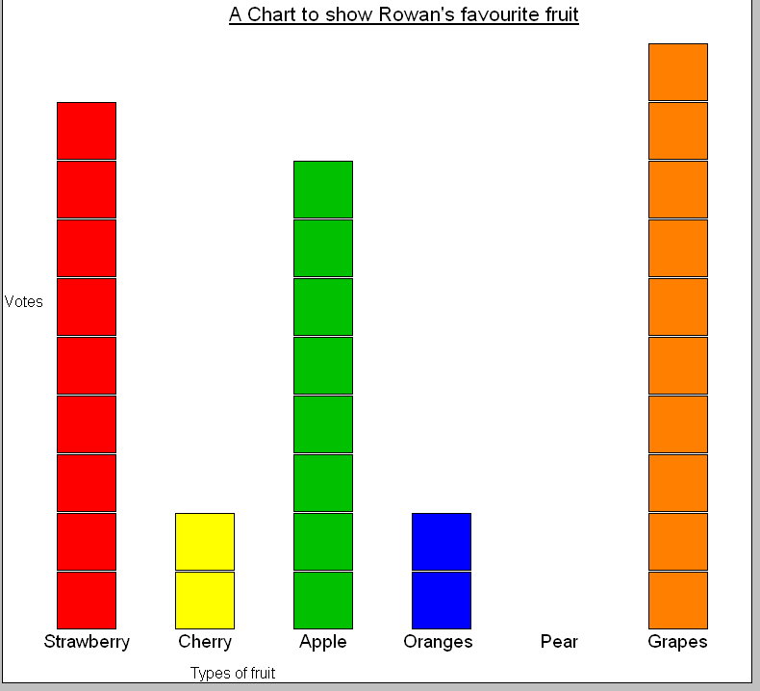

1. First, can you correct the graph? Pear hasn’t been given any votes, but it should have 1! Can you make it so Pear has 1 vote?

Then can you answer the following questions?

2. How many more people voted for strawberry than cherry? ________

3. Which fruit got the most votes? ____________________________

4. Which two fruit got the same amount of votes? _______and_______

5. How many people voted for cherry and oranges together? _________

Here is a pictograph that shows peoples favourite holiday location:
America:

Country
Spain:

France:

Scotland:
1 vote = 1 flag

Can you answer the following questions?

- Which country was the most popular? ____________________

- Which country was the least popular? ____________________

- How many more votes did Scotland get than France? _________

- How many people voted altogether? _________people

Here is a pictograph that shows peoples favourite holiday location:
America:

Country
Spain:

France:

Scotland:
1 flag = 2 votes

Can you answer the following questions?

1. Which country was the most popular? ____________________

- Which country was the least popular? ____________________

- How many more votes did Scotland get than France? _________

- How many people voted altogether? _________people

- How many people voted for America? _____________
How do you know this? _________________________________
____________________________________________________________________________________________________

