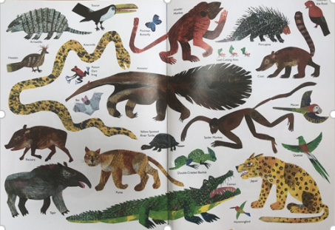
Draw two animal characters from the story and then write as many adjectives as you can to describe them.

