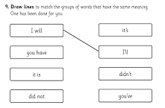
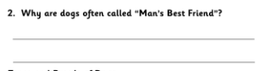
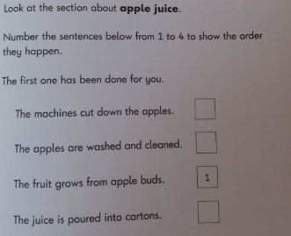
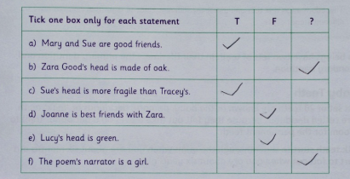
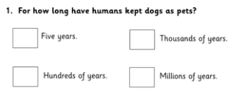
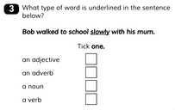
Remember there are different ways of asking questions. Maybe you could try to use a selection of question types.
Also remember some questions ask you to use different skills – Have a look at “The Friendly Comprehension Canine” information sheet to remind you!

