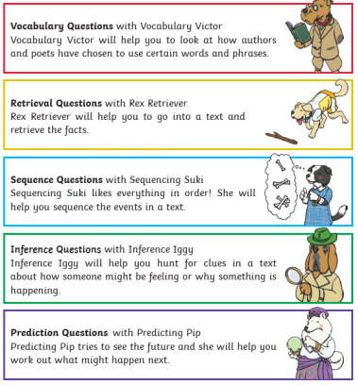
The Friendly Comprehension Canines

