al | el | il | le | al
il | el | il | le | al
el
il
le


Player 1 pulls a card from the pack without showing Player 2.

Player 1 reads the word to Player 2.

Player 2 writes the word on a whiteboard, choosing the correct ending.

Player 1 checks to see if it is spelt correctly.

If the spelling is correct, Player 2 moves his counter to the next space with that ending on it.

Then it is Player 2’s turn to choose a card for Player 1.
The apple and the camel

al | el | il | le | al
al | el | il | le | al
el
il
al | el | il | le | al

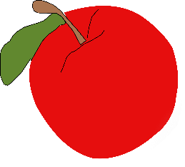



tickle | barrel | hotel | camel
animal | rubble | bible | apple
petal | little | capital | squirrel
table | hospital | tunnel | pencil
gerbil | gerbil | pedal | metal
evil | basil | fossil | pupil

