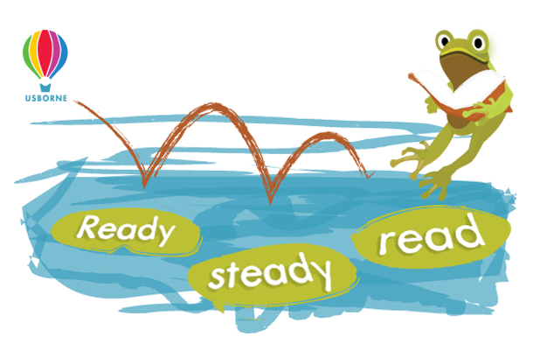


Dear Parent/Guardian,

To celebrate and encourage a lifelong love of reading at home and school, we will be running a sponsored read between 01/03/2021 and 07/03/2021.

The project is being organised in conjunction with our local Usborne Organiser, Izabela Olendzki, and all the money raised will go towards brand new books for our school.

In addition to the sponsorship money, Usborne will also donate up to 60% of the total raised in EXTRA FREE BOOKS to the school. So for every £600 raised, we will get an extra £360 in FREE Usborne books!

Please help us to enhance our reading resources for pupils by encouraging your child to spend a small amount of time each day either reading to themselves, to others, or being read to. They can read books, comics, magazines, newspapers, menus, websites, recipes, poems, leaflets, instructions – anything with words!

If you are able to support our sponsored read, please find enclosed a sponsorship form for your child. A reading log, to record the minutes they have spent reading, will be given to them in class or sent via Google Classroom.

After the sponsored read, please send all the sponsorship money via this Just Giving page by 12/03/2021.

Cheques should be made payable to Izabela Olendzki.

We look forward to having lots more books for your child to read, share and enjoy.

For more information, contact Izabela Olendzki, Independent Usborne Organiser, or visit us online: www.usborne.com/schools

