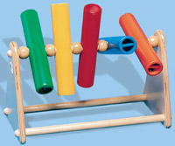
Flip fingers

Brightly coloured tubes with bells inside which revolve at the slightest touch.
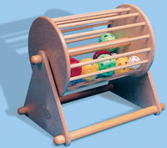
Large rotating drum

Coloured balls and bells inside the drum provide both visual and auditory stimulation
Mirror merry go round

A simple but extremely effective spinning toy which reflects light and images in its mirrored panels as they jingle and chime on the rotating merry-go-round
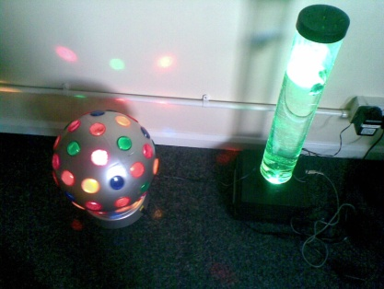
Large bubble tube and disco ball

can be used with a soft switch in a velvet case allowing children with limited mobility to control the function of either piece of equipment
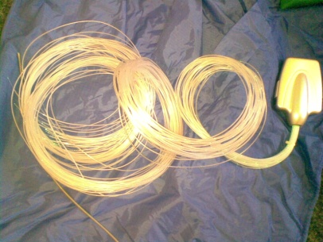
Hand held fibre optics

Thin fibre optic strands that change colour in your hand (battery operated)
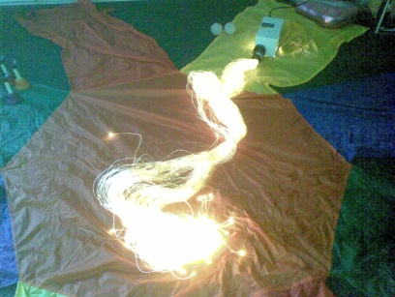
Fibre Optic Kit

Fibre optic strands provide a stunning, visual and tactile experience. They are safe to stroke, hold, wrap around the body and lie among.
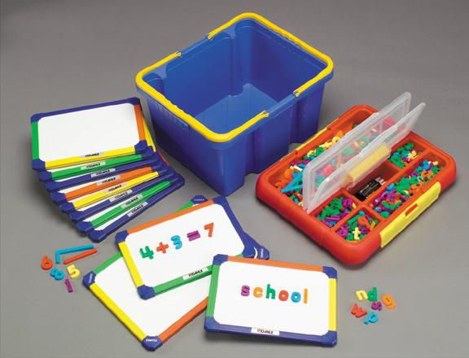
Magnetic class pack

10 x A4 magnetic dry wipe boards and 1 x A3 magnetic dry wipe board with magnetic numbers and letters
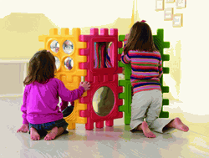
Tactile shapes for children to build.

Includes anti shatter convex and concave mirror blocks
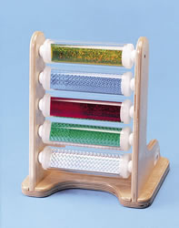
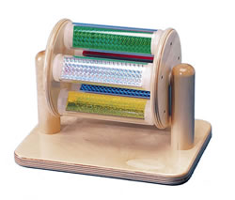
Diffraction tube and drum
Toys that turn or rotate at the slightest touch
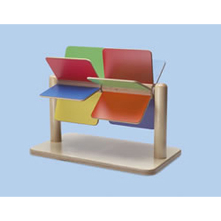
Paddle Wheel

A brightly coloured low effort toy
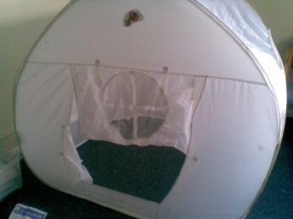
Sensory tent
140cm x145cm

White pop up tent that can be transformed into either a stimulating or calming sensory environment
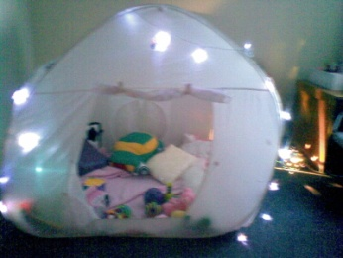
Tent shown draped with fairy lights on the outside and soft pink fleece blanket and multisensory cushions inside
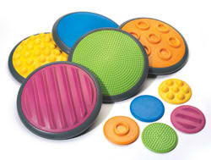
Tactile disks
Challenge children’s sense of touch on both hands and feet
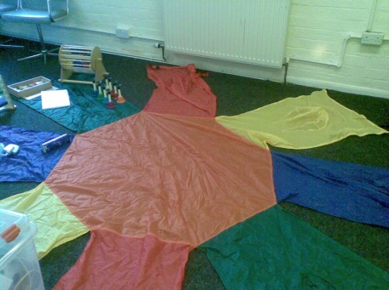
Sunflower parachute

To add variety to parachute play

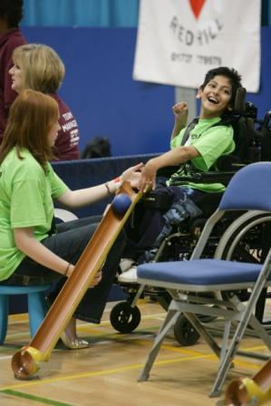
Boccia
An exciting and skilful indoor game where coloured leather balls are aimed at a white target ball

The rules of boccia allow the use of a ramp to help throw the balls, so that people with very serious disabilities can take an equal part in skilled competitive play.
Soft dolls with disability accessories for inclusive play
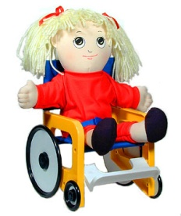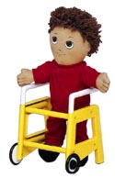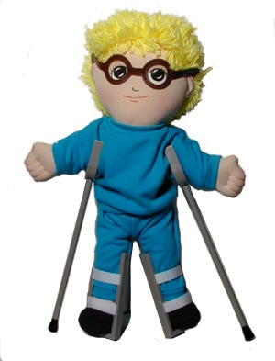


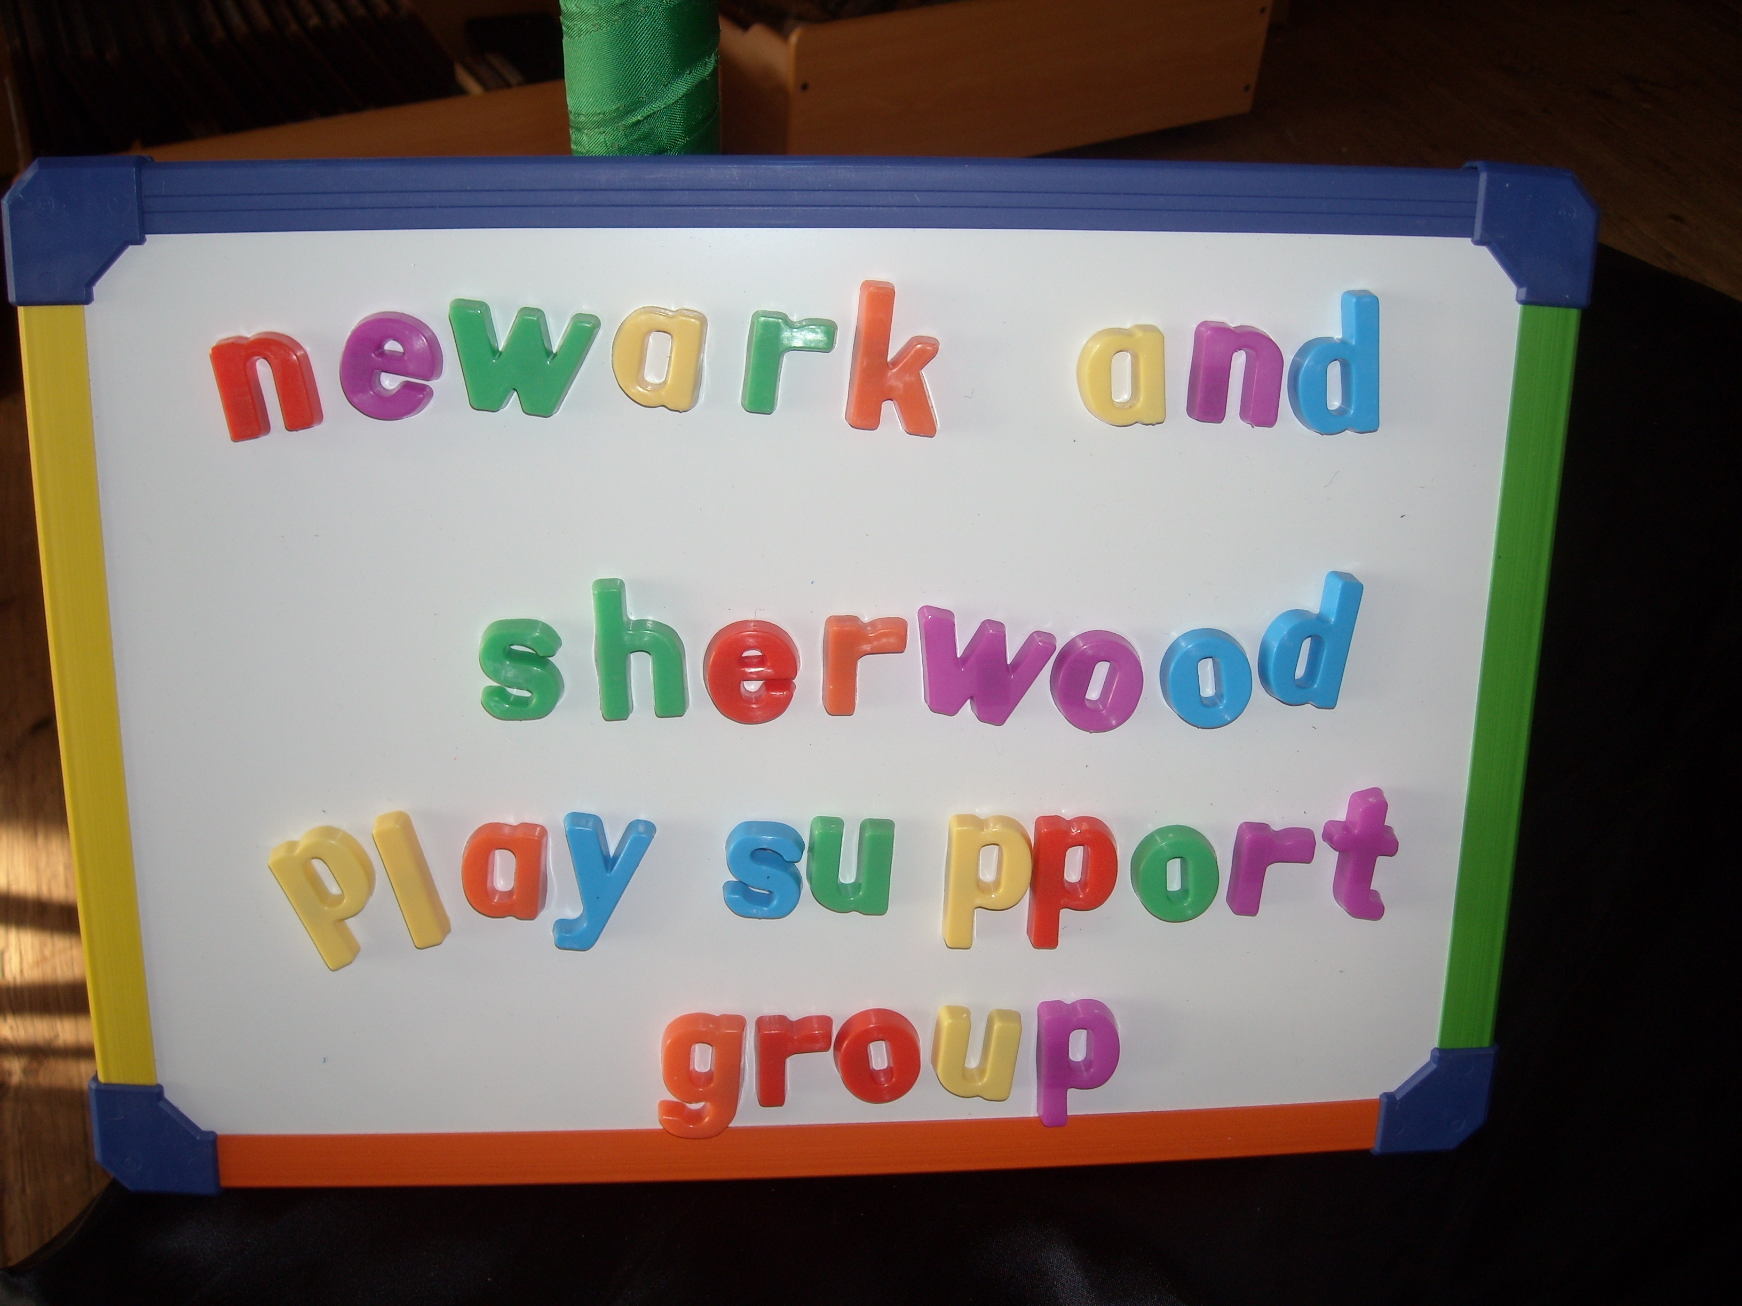
Inclusion Resources & Equipment for Hire
To book resources please contact us on
01636 647121
Or email playsupport@btconnect.com
Aimimg High for Disabled Children
Short Breaks Pathfinder Project

